|  |
| --- |
|  |
| **COMP.6215 Graphical User Interface Programming** |
| **Assignment 1** |

|  |
| --- |
| Jee Won/Elly Woo  2023-8-11 |

Content

Concept 2

Concept idea 2

Concept breakdown 3

Structure 4

Interaction 0

Main page 0

Beverage page 0

Fortune-telling feature (Tarot card reading) 1

Turkey’s coffee fortune telling 2

Fortune cookie 3

About us 0

Visual 0

Mood board 0

Consideration 0

# Concept

## Concept idea

The concept of the application is the fortune teller café. This application could offer the great opportunity of interactive virtual fortune telling experience with variety beverages for users.

Furthermore, it develops a unique and appealing platform that offers users mystical insights and enjoyable refreshment options by combining fortune-telling entertainment with a cafe atmosphere.

There are some features of this application.

**Fortune-telling feature**

The application offers the tarot card page to predict the user’s future with a unique interface design. Then, it provides users to choose 3 cards from the screen and will display the reading of the cards.

**Café beverage**

We also offer a list of many ranges of coffee and drink menus with suitable theme designs with the application.

**Fortune-cookie**

This page provides the big fortune cookie image and prompts them to click on it to insight into their feature or worry. After clicking, a random sentence will pop up on the screen.

**Turkey’s coffee fortune telling**

The Café beverage menu has Turkey’s coffee, and it also can be the unique method of fortune telling. It displays the photo list of patterns of coffee left over and shows the details of the results. This feature encourages the users to join the self-fortune reading.

## Concept breakdown

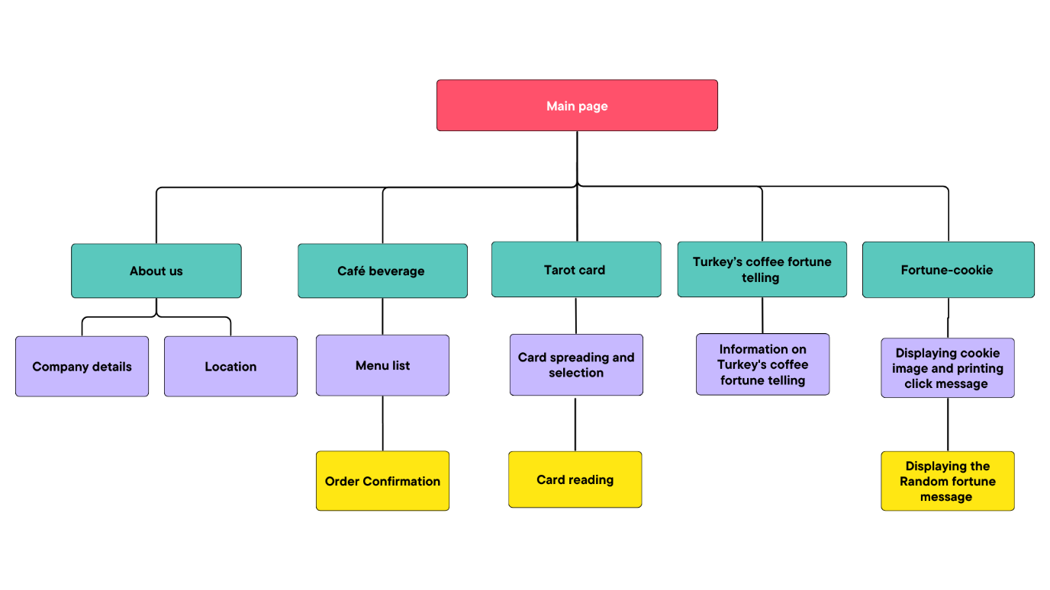

# Structure

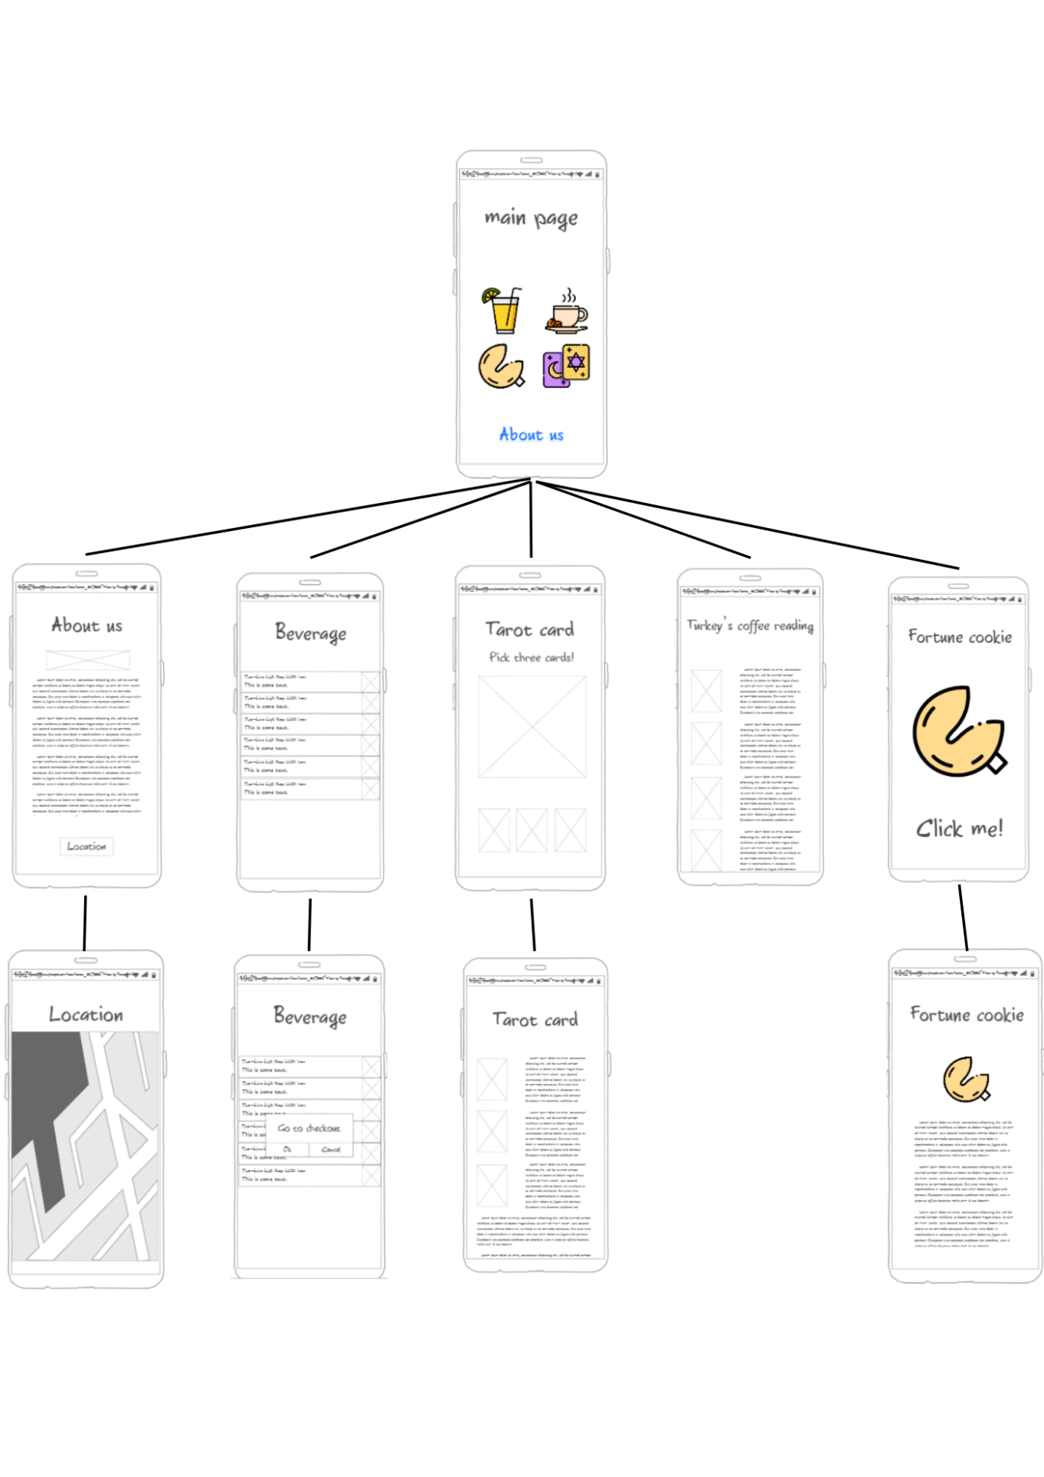

# Interaction

## Main page

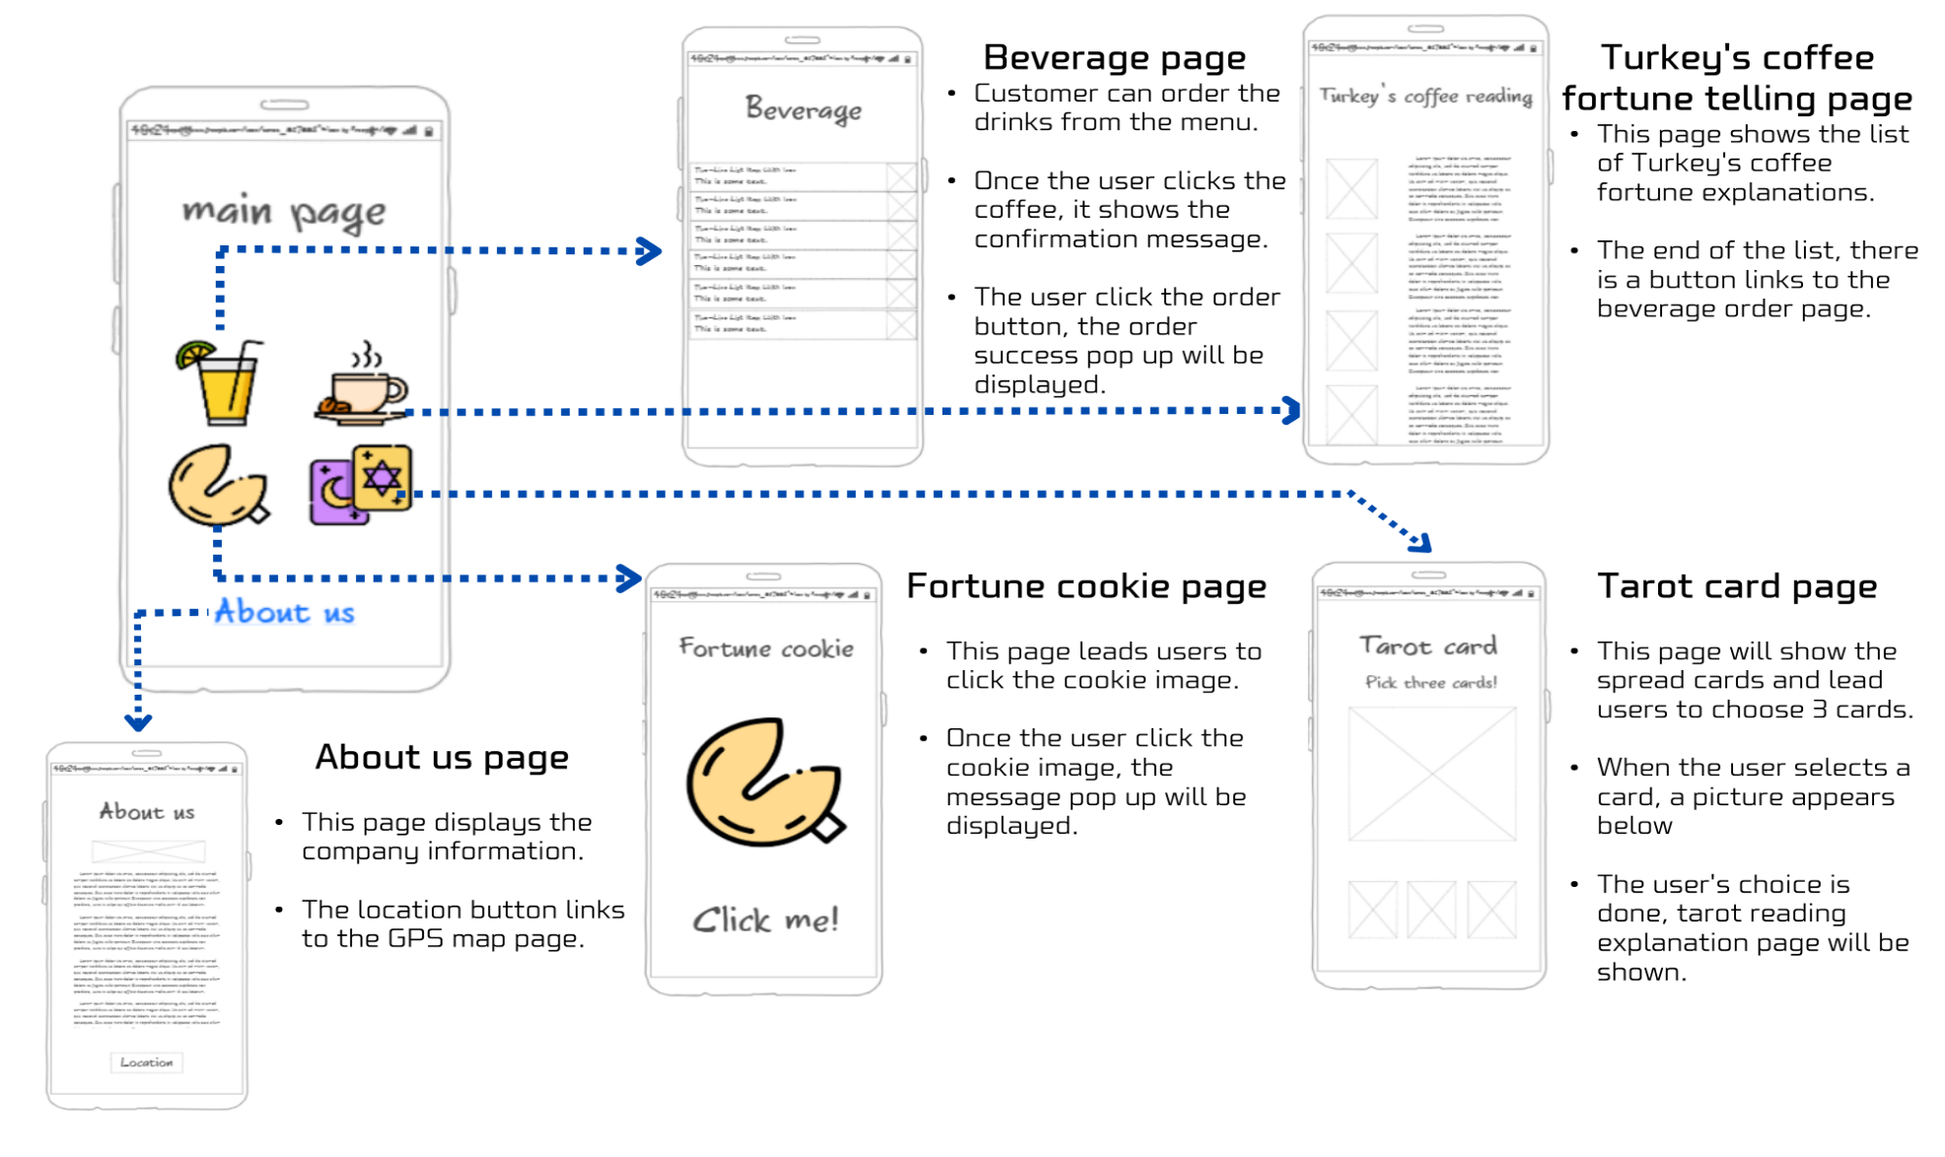

## Beverage page

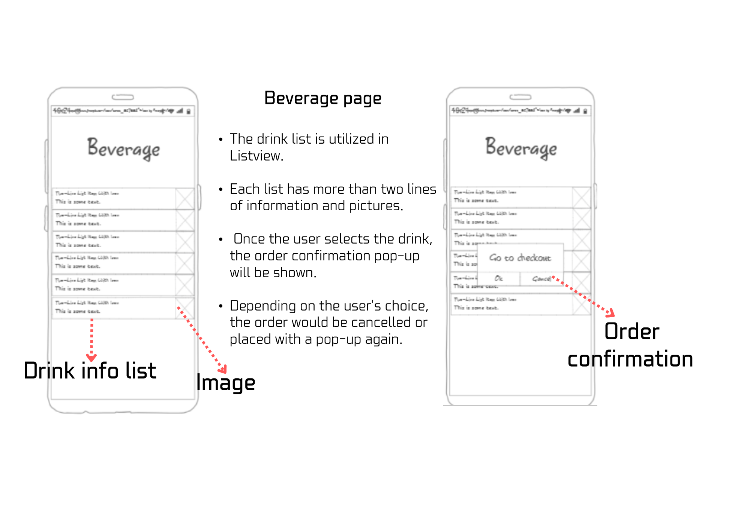

## Fortune-telling feature (Tarot card reading)

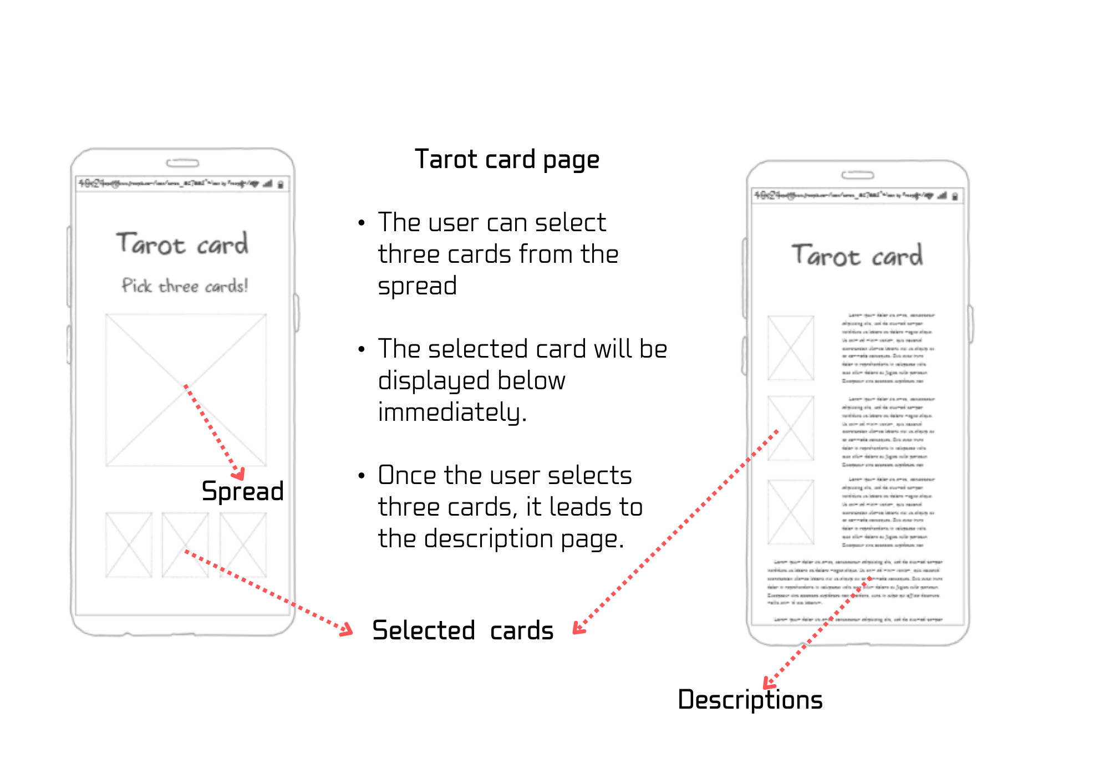

## Turkey’s coffee fortune telling

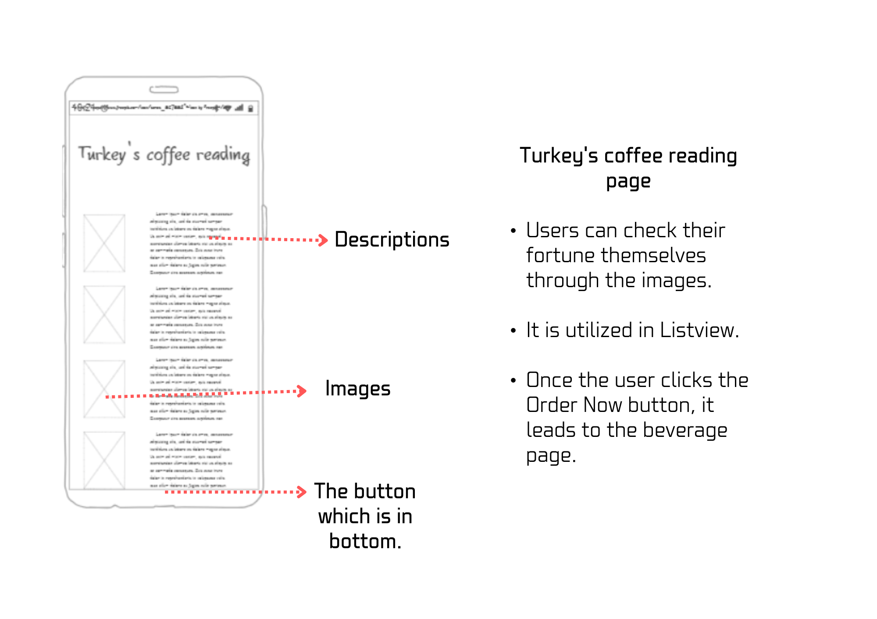

## Fortune cookie

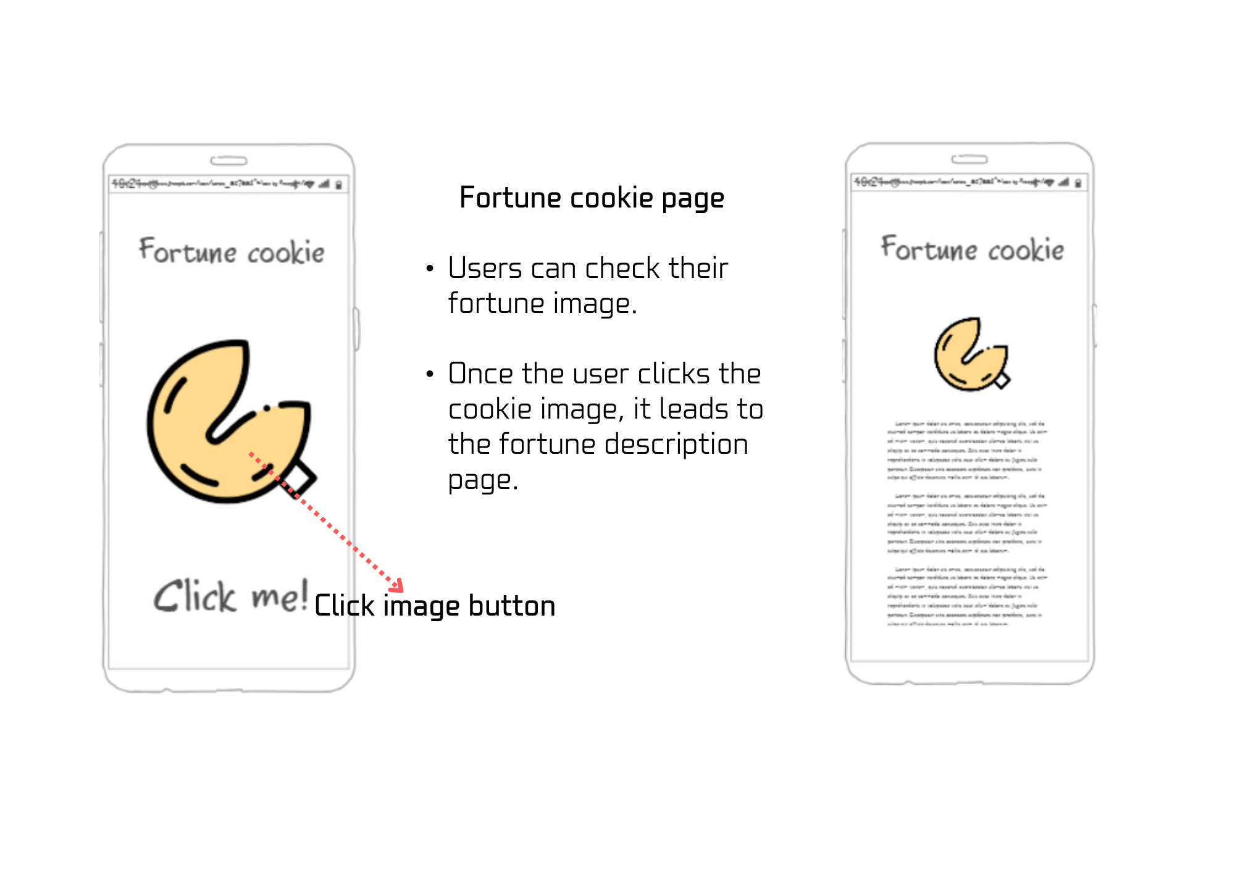

## About us

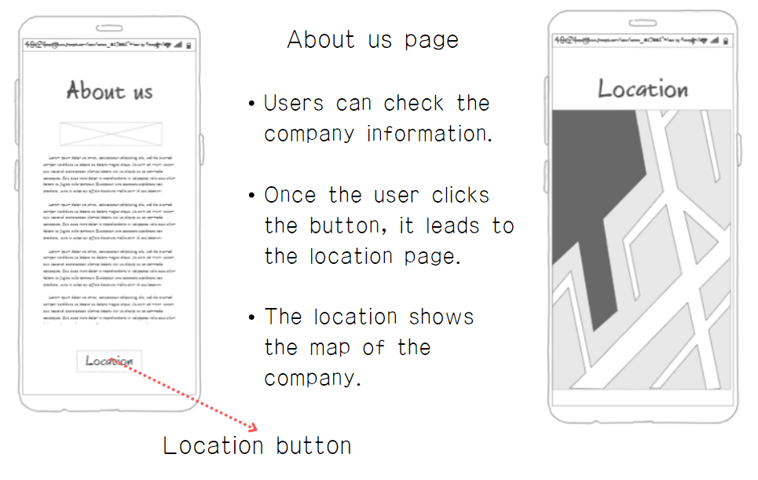

# Visual

## Mood board

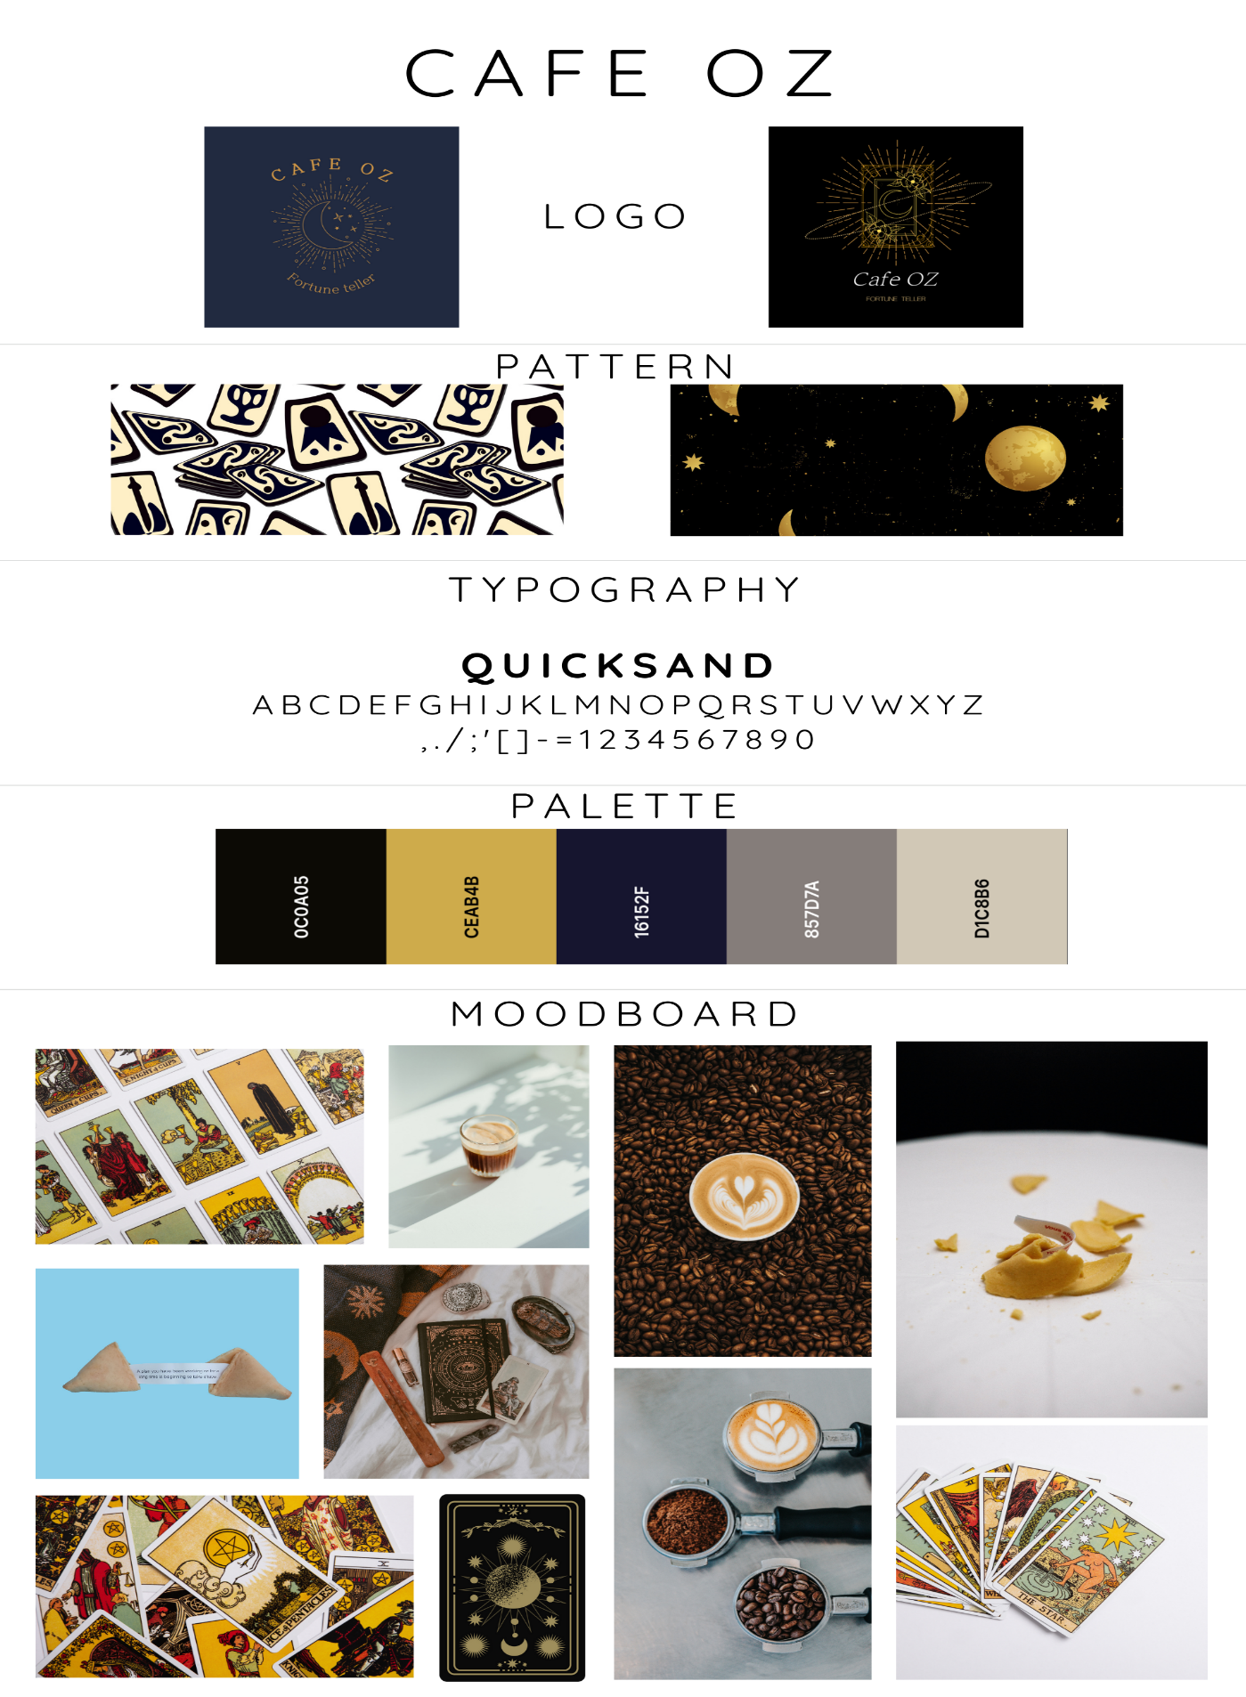

## Consideration

